JSON Parsing & Stringification

🌟 What is this topic about?

🌟 What is this topic about?
# Source: AI Source: Provided by: [Data Path: Persons Table -> ID Column: 1, Name_En Column: Motasem Essam] -> From: [ChatGPT] on [5/31/2026]
This topic explains how JSON is converted back and forth between text and usable data in programming.
It is one of the most important parts of working with APIs and web apps.

🔄 1. JSON Parsing (JSON → Object)
# Source: AI Source: Provided by: [Data Path: Persons Table -> ID Column: 1, Name_En Column: Motasem Essam] -> From: [ChatGPT] on [5/31/2026]
🌟 Definition
Parsing means converting a JSON string into a real object that a program can use.

📥 Deserialization
Deserialization is the process of converting JSON data back into a usable object in a programming language.

📦 Example (JavaScript)
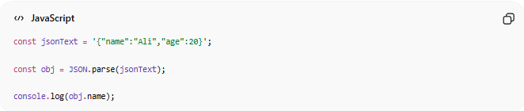
const jsonText = '{"name":"Ali","age":20}';
const obj = JSON.parse(jsonText);
console.log(obj.name);
👉 Output: Ali

🧠 Simple Idea
📥 You receive JSON → you “open” it → you get usable data

📤 2. JSON Stringification (Object → JSON)
# Source: AI Source: Provided by: [Data Path: Persons Table -> ID Column: 1, Name_En Column: Motasem Essam] -> From: [ChatGPT] on [5/31/2026]
🌟 Definition
Stringification means converting an object into JSON format so it can be sent or stored.

📦 Serialization
Serialization is the process of converting a data structure or object into a format that can be stored or transmitted, usually JSON.

📦 Example (JavaScript)
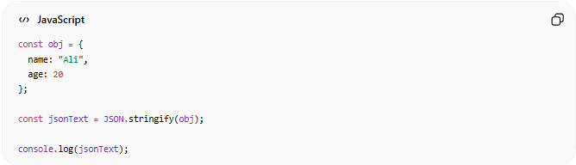
const obj = {
name: "Ali",
age: 20
};
const jsonText = JSON.stringify(obj);
console.log(jsonText);

🔁 3. Full Conversion Cycle
# Source: AI Source: Provided by: [Data Path: Persons Table -> ID Column: 1, Name_En Column: Motasem Essam] -> From: [ChatGPT] on [5/31/2026]
JSON String → Parse → Object → Modify → Stringify → JSON String

🌐 4. Why We Use Parsing & Stringification
# Source: AI Source: Provided by: [Data Path: Persons Table -> ID Column: 1, Name_En Column: Motasem Essam] -> From: [ChatGPT] on [5/31/2026]
- Send data to APIs 📡
- Receive data from servers 📥
- Store data in databases 💾
- Share data between systems 🌐

⚙️ 5. Real API Example
# Source: AI Source: Provided by: [Data Path: Persons Table -> ID Column: 1, Name_En Column: Motasem Essam] -> From: [ChatGPT] on [5/31/2026]
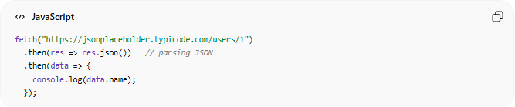
fetch("https://jsonplaceholder.typicode.com/users/1")
.then(res => res.json()) // parsing JSON
.then(data => {
console.log(data.name);
});

🧠 Simple Analogy
# Source: AI Source: Provided by: [Data Path: Persons Table -> ID Column: 1, Name_En Column: Motasem Essam] -> From: [ChatGPT] on [5/31/2026]
Think of JSON like:
📦 A sealed package
- Parsing = opening the package 📥
- Stringification = packing it back 📤

⚠️ Common Mistakes
# Source: AI Source: Provided by: [Data Path: Persons Table -> ID Column: 1, Name_En Column: Motasem Essam] -> From: [ChatGPT] on [5/31/2026]
- Forgetting to parse JSON before using it
- Sending objects without stringifying them
- Invalid JSON format

🧭 Summary
# Source: AI Source: Provided by: [Data Path: Persons Table -> ID Column: 1, Name_En Column: Motasem Essam] -> From: [ChatGPT] on [5/31/2026]
JSON parsing converts JSON text into usable objects, while stringification converts objects back into JSON so data can be sent, stored, or shared between systems.

